Documentation by Simerpreet Singh

INTRODUCTION

This documentation is the brief for the assignment we made for video rental system, which has the information regarding movies, clients, business details. We can edit and save the data as well.

Sign-In Page

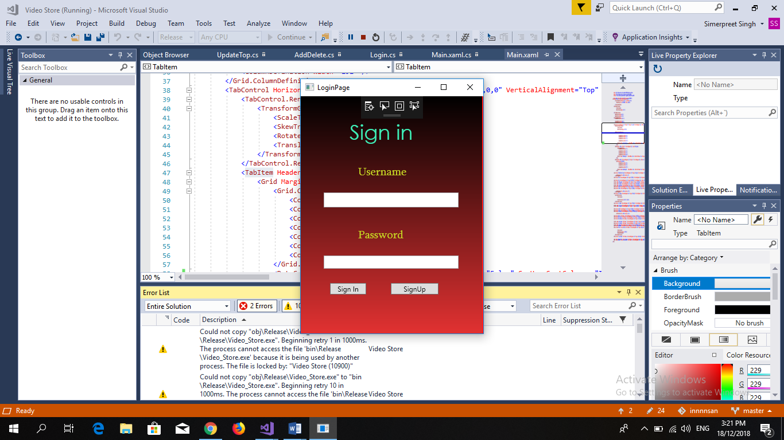

Sign-in allows to register a new person and allows the previous person to login the site with existing credentials.

Sign-Up Page

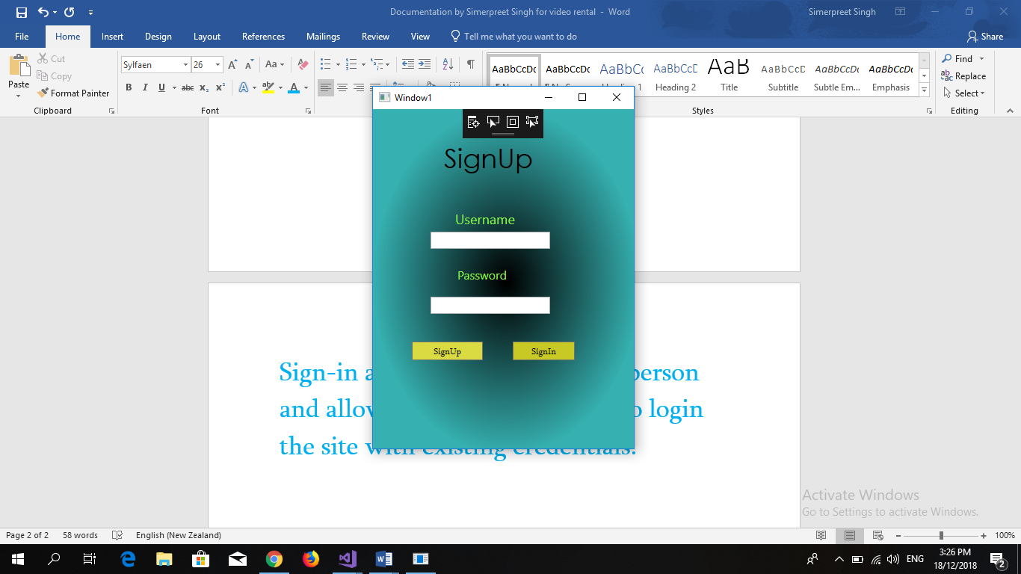

Sign-Up page allows a new person to register in site in order to be able to use the video rental system.

Video Rental System

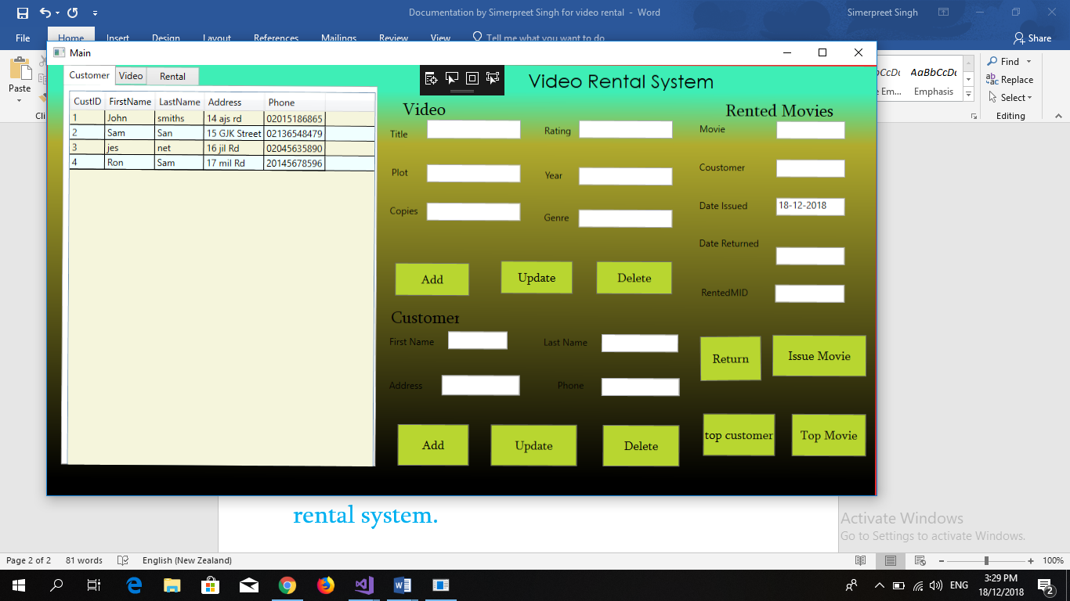

After doing Sign in and Sign up process the final window pops up that is video rental system as shown in the above picture. This is the main window which allows the person to do all the stuff like add, update or delete a movie and a customer. As well as the user can also find the record for top movie issued by the people for rent and the top customer who has issued most movies among all.

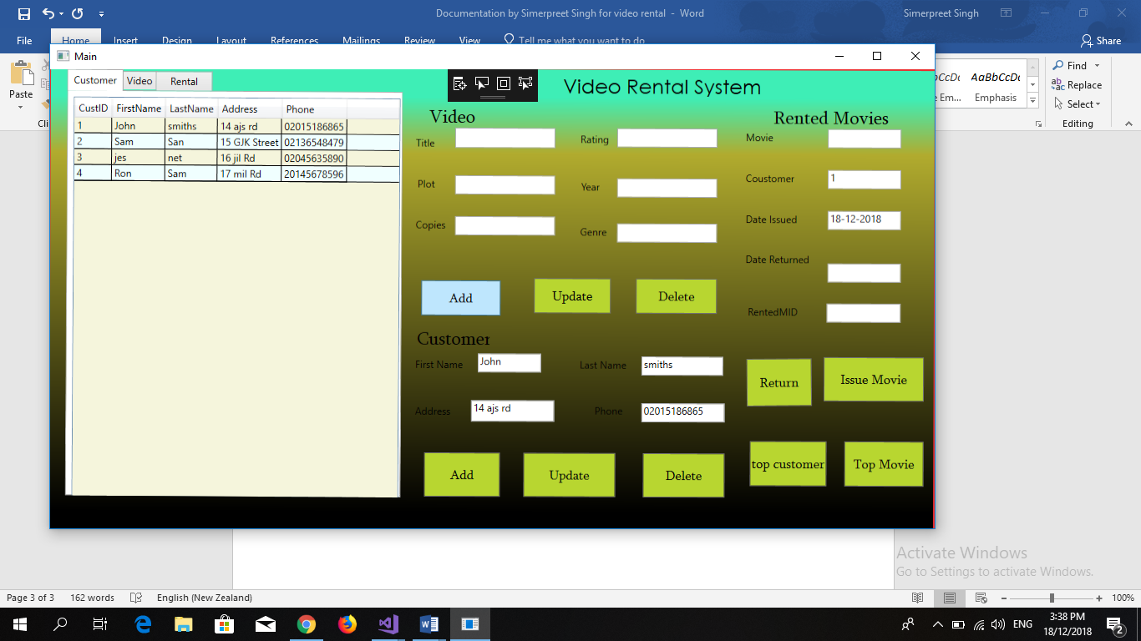

As shown in the above picture if you want any information for customer, video and rental just click any of the button shown in data grid view and the information will be displayed in the window and after that just double click on name or the movie and all the information will be transferred to the text box and add the changes and click the update button and the information will be update everywhere even in database also.

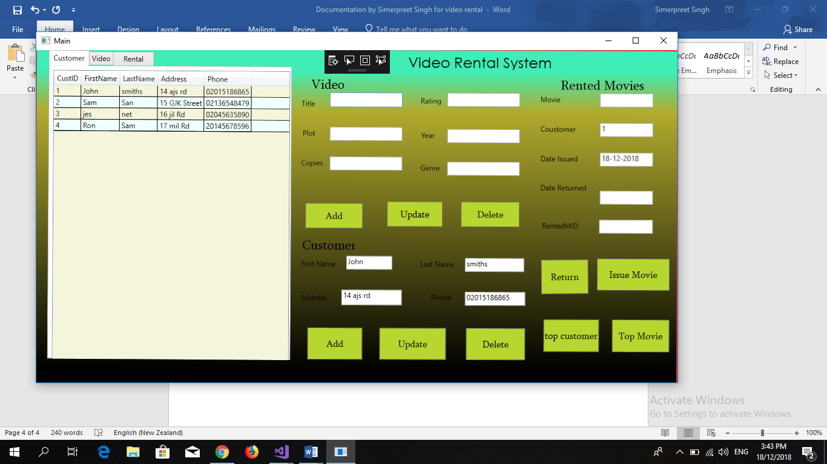

And if you want to add any video, customer just fill all the information as shown in the above picture and click on add button and the information will be add everywhere even in the database.